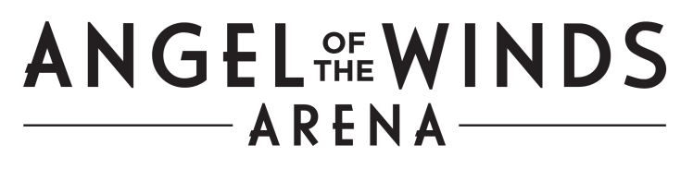

Everett Public Facilities District

Board of Directors Agenda
SPECIAL BOARD MEETING
2000 Hewitt Avenue
Conference Room 2
8:00 a.m., December 16, 2021

SPECIAL MEETING NOTICE

Per RCW 42.30.080, you are hereby notified that the Everett Public Facilities District will meet on Thursday, December 16, 2021. This notice is required because the meeting is held outside its regularly scheduled date/time and/or place.

At 8:00 a.m., a Special Meeting will be called to order in Conference Room 2 of the Edward D. Hansen Conference Center, located at 2000 Hewitt Avenue, Everett, WA 98201.

This meeting will replace the regularly scheduled December board meeting that was cancelled. The meeting is scheduled to conclude at 9:30 a.m. and is open to the public.

The agenda for this meeting has been posted on the Angel Of The Winds Arena website and can be found at: https://www.angelofthewindsarena.com/about/public-facilities-district.

